MENTAL HEALTH, VIOLENCE

MARIJUANA IS THE COMMON WEB BETWEEN SO MANY MASS KILLERS

Feb 2025 15-year-old shoots mother, sister after taking bunch of edibles
A 15-year-old boy in Houston is in custody after allegedly shooting his mother and 17-year-old sister multiple times late Saturday night. Police say the teen had ingested a large amount of marijuana edibles and had a bad reaction before finding a gun and opening fire. Both victims were taken to the hospital in critical condition. Before the shooting, the teen reportedly called 911, saying he might harm himself or others. Firefighters arriving at the scene found him in a parking lot, where he briefly pointed a gun at them before fleeing. Police later arrested him.

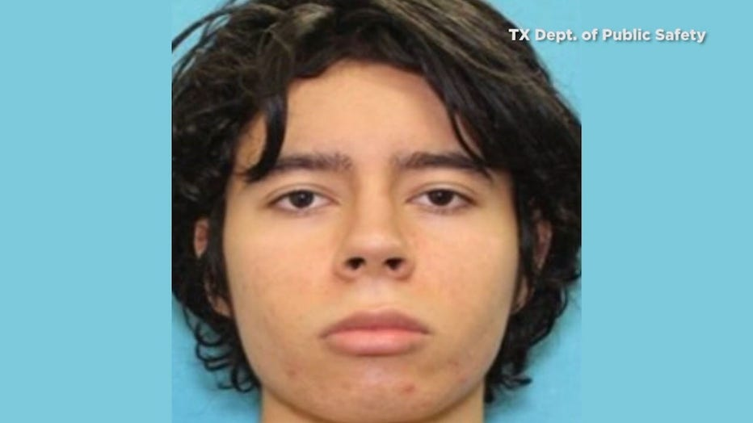
18-year-old Salvador Ramos known regular marijuana user. Shot his grandmother in the face on May 24, 2022, and then went to Robb Elementary School and fatally shot 19 students and 2 teachers, while injuring 17 others. Ramos was killed 74 minutes after entering the classroom by law enforcement officers.

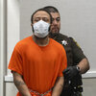
2021 A Wisconsin man driving high on marijuana when he drove his SUV through a Christmas parade killing six people including 8-year-old Jackson Sparks, who was marching in the parade with his baseball team, and three members of the Dancing Grannies, a group of grandmothers that dances in parades. Dozens of other people were hurt, some severely.
The jury found Darrell Brooks guilty of six counts of first-degree intentional homicide. He faces a mandatory life sentence on each count.

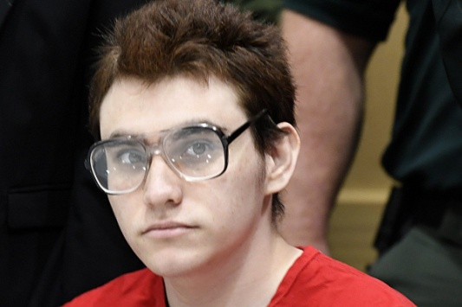
Parkland Shooter Killed 17 . Nikolas Cruz, the teen who confessed to having killed 17 people at a Florida high school, told investigators that he heard voices in his head telling him to "burn, kill, destroy" and that he tried but failed to kill himself two months before the massacre, according to a just-released transcript of his first formal interview with authorities. During the interview, he says that he had used a lot of marijuana and had taken a lot of the prescription tranquilizer Xanax.

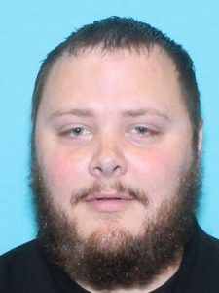
JULY 3, 2018
A toxicology report on Devin Patrick Kelley, who shot and killed 26 at a church in Texas on November 5, revealed marijuana.
As Senator Chuck Schumer moves to decriminalize marijuana, he should scrutinize why marijuana plays a role in so many mass killings. The toxicology screen of mass killer Devin Patrick Kelley revealed marijuana in his system when he killed 26 people at a Texas church last November. A week after the killings in Texas, California “pot farmer” Kevin Neal murdered five people and injured eleven others. Marijuana, or heavy use of marijuana at a young age, is a common web between many mass killers.


Diagnosed with cannabis-induced psychosis, Satoshi Uematsu killed 19 handicapped people in Japan and injured many others.
Although Devin Kelley had an anti-church bias, other marijuana-using killers express different ideological bents. Satoshi Uematsu, hated handicapped people whom he considered a burden on society. The Japanese man who stabbed and killed 19 disabled people in 2016 frequently advocated for marijuana legalization. Just weeks before his attack, Uematsu had been diagnosed with cannabis-induced psychosis and paranoia.

In 2013, President Obama’s director of drug policy, Gil Kerlikowske released a study which cited marijuana as the drug most commonly linked to crimes. The links between marijuana and violent behavior transcend national, religious and racial divides. (Read the two most recent cases of religious violence.)


Jared Loughner, killed six and injured many in Tucson, AZ, 2011.
Heavy or very heavy use of marijuana at a young age links several gunmen and terrorists with or without ideologies: Planned Parenthood shooter Robert Dear; Aurora shooter James Holmes;
Tucson shooter Jared Loughner, and the Chattanooga shooter Mohammed Abdulazeez.

The Teen Brain
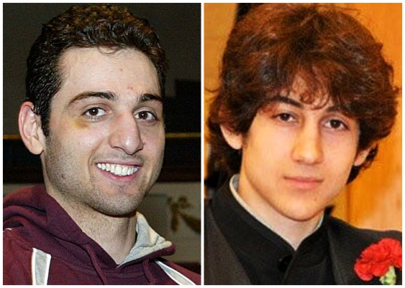
The Boston bombers, Tamerlan and Dzhokhar Tsarnaev, had been heavy, persistent teenage marijuana users. A study from the University of Pittsburgh shows strong changes may affect the adolescent user years later, even after stopping the use of marijuana.
Marijuana was intricately tied to the Boston bombers, the Oklahoma City bomber and the Bastille Day terrorist in Nice. Brahim and Salah Abdeslem, who planned killing 130 at a Paris night club, and Cherif Kouachi, of the Charlie Hebdo killings, also belonged to the complicated web of heavy, chronic marijuana users. The perpetrators of bombings in Londonand Manchester were known to be heavy marijuana users.

When Marijuana Use Leads to Acute or Chronic Psychosis
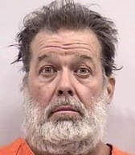 Robert Dear, Planned Parenthood shooter, November 27, 2015
While around 50% of American adults have tried marijuana, only 10-13 % of adults smoke pot on any regular basis. Pot-using mass killers often stand out because of the chronic and obsessive nature of their marijuana habit. Planned Parenthood shooter Robert Dear appears to have moved from North Carolina to Colorado, fixated on his desire to be high.

A significant chunk of marijuana users experience psychotic symptoms. Psychotic killers with mental illness may appear different from political and religious killers, but they often share the trait of persistent, early marijuana use.
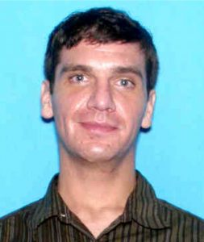
Noah Harpham, was in mania when he shot three people in Colorado Springs in 2015.

Noah Harpham, who shot three people in Colorado Springs weeks before the Planned Parenthood shootings, experienced early pot addiction and tried to recover. When he used marijuana again after Colorado legalized it, he immediately went into psychosis. Shortly before the shooting rampage, he had been trying to get mental health treatment. His toxicology report tested THC+, and no other drugs were found.
Aurora, Colorado theater shooter, James Holmes, was a heavy marijuana user. A neighbor reported regularly seeing him smoking weed behind his apartment, but never talked to him.

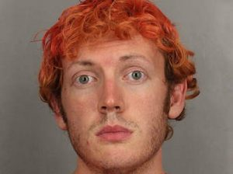
James Holmes, Aurora shooter used to smoke weed behind the apartment.
The Chattanooga shooter suffered mainly from depression and/or bipolar disorder, and may not have been driven as much by ideology as the other mass shooters. Heavy marijuana use was an essential part of his life, and it had prevented him from getting a job.

Nice terrorist Mohammed Bouhlel smoked very strong weed in high school, and had his first psychotic break at 19.
The Nice terrorist, Mohammed Bouhlel, plowed into the crowd with a truck on Bastille Day two years ago, killing 86 people. Bouhlel had a history of smoking strong cannabis as a teen. He had an early psychotic break at age 19, a few years before the move to France. His psychosis predated his interest in jihad, which had begun only a few months before the Bastille Day attack. Bouhlel also took steroids and pharmaceutical drugs years later, but started his drug use with weed.
In 2014, Washington State high school student Jaylen Fryberg shot five friends whom he had invited to eat lunch with him. On Twitter he revealed the need to smoke a ton of pot because of a breakup. The girl who had broken up with him said on Twitter that smoking pot made him stupid. He was only 15 at the time, but Washington State started selling commercialized pot about four months earlier.
Marijuana strongly alters the teen brain, and a recent study from Montreal pinpointed that any user under age 25 can become of victim of psychotic symptoms.

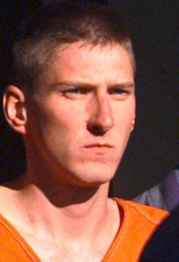
Oklahoma City bomber Timothy McVeigh killed 168 in 1996
Another pair of high school shooters, the Columbine shooters, chose to do their rampage on 4/20, a symbolic date for junkies. Timothy McVeigh also chose this day for the Oklahoma City bombing.
Were the DC Snipers, John Allen Muhammed and Lee Boyd Malvo, pot users? They fit into a pattern of an older man using marijuana to control a teenager. Before ending up in the DC area, they moved between places known for marijuana: Jamaica, Antigua, Bellingham, Tacoma.

When Marijuana Psychosis Leads to Violence: Aurora, Arizona
Some the most notorious recent murderers who were marijuana users fell victim to psychosis and delusion: Aurora shooter Holmes, Tucson shooter Loughner, Planned Parenthood shooter Robert Dear and Eddie Routh. Routh shot “American Sniper” Chris Kyle and Chad Littlefield because of his paranoia. He smoked marijuana the day of the murders. Suffering from PTSD, he thought the other men would hurt him.
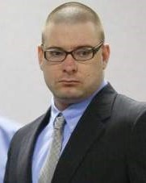
Eddie Routh, veteran with PTSD, smoked pot the morning before he killed Chris Kyle Chad Littlefield.
The Planned Parenthood shooter in Colorado Springs, Robert Dear, appears to have been both ideologically fanatic and psychotic. Eric Rudolph, another infamous anti-abortion terrorist, also had a marijuana history –the reason for his discharge from the Army.

The 15% or so of marijuana users who experience psychotic symptoms from marijuana or go into permanent psychosis (schizophrenia) are 9x more likely to become violent than schizophrenics whose illness has nothing to do with drugs. *

Marijuana often creates a cat-and-mouse chase with depression, bipolar, anxiety disorders and schizophrenia, and it makes these conditions worse. 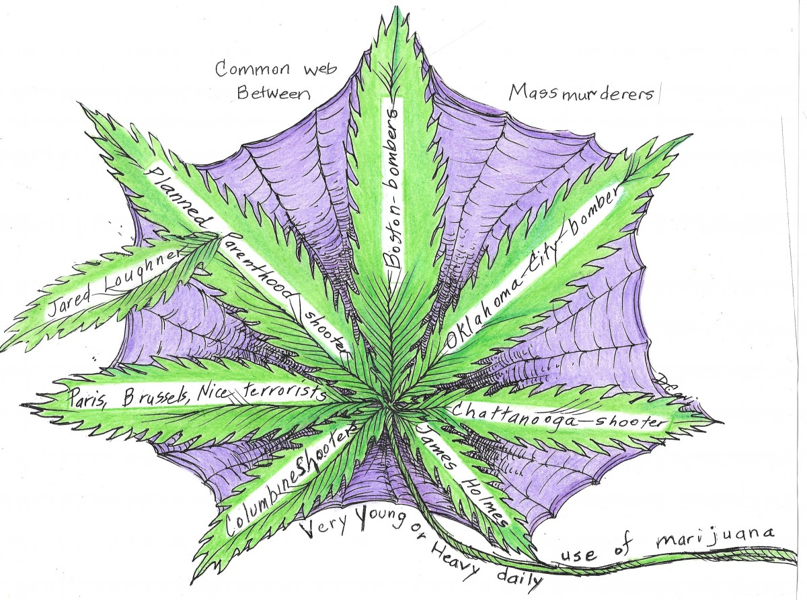
Educating about the connection between drug use and violence with an eye on drug prevention could alleviate much violent crime.

Solution to Cutting Down Mass Violence
Americans argue over the most effective means to stop mass killers.
Discussions often leave out one of the most important components of violence……compulsive drug use, especially marijuana. Let’s consider that the root of violence goes much deeper than a person’s religion, gun laws or innate mental illness. Let’s stop legalizing drugs.
A Secret Service report on mass attacks in public places, 2017, connected 54% of attackers to illicit drugs or substance abuse.


Manchester terrorist Salmon Abedi
We acknowledge that not everyone who uses marijuana becomes mentally ill or psychotic. However, cannabis use, especially in young users can cause extraordinary changes to the brain.

Read how Salman Abedi changed from a cannabis smoking teen to an Isis terrorist.

Robert Durst, who allegedly murdered several people throughout the United States depended upon his “beloved marijuana.”

Readers should check out the many excellent sources describing links between marijuana, mental illness and violence, including:

*Fazel S, Långström N, Hjern A, Grann M, Lichtenstein P. Schizophrenia, substance abuse, and violent crime. JAMA. 2009 May 20;301(19):2016-23.

Miller, Norman S Miller and Thersilla Oberbarnscheidt. Marijuana Violence and Law. Journal of Addiction Research & Therapy, January 17, 2017

Harris AW, Large MM, Redoblado-Hodge A, Nielssen O, Anderson J, Brennan J. Clinical and cognitive associations with aggression in the first episode of psychosis. Aust N Z J Psychiatry. 2010 Jan;44(1):85-93..……

